Energy Café A mobile off-grid kitchen resource.

Blog: www.energycafe.wordpress.com
Email: pilotpublishing@ googlemail.com

“You never change anything by fighting the existing reality.
To change something, build a new model that makes the existing model obsolete.” Buckminster Fuller

Energy Café revolves around its’ mobile hub: a converted horse trailer.

This is its’ inventory.

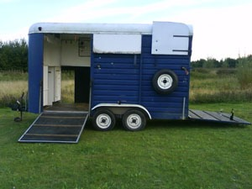

Trailer: Fibre-glass roof, steel and wood
Dimensions:

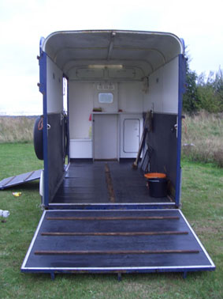

Doors: Jockey door, Back ramp & Side ramp (both potentially extending to create more interior space with awnings)

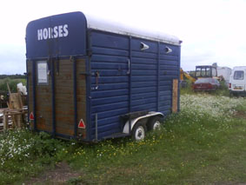

Exterior: Currently in its original blue colour - the exterior body of the trailer will gradually be customised as it moves, collecting stories, comments, drawings, stencils, tags etc en route

Currently the trailer is stationed on Private Land, Waltham Abbey, Essex.

The trailer is being customised into an off grid kitchen:

Different people have made various components that fit inside. This includes portable units that can be taken out to create various outdoor eating/cooking areas. Everything is made by hand from recycled and donated materials.

Installed so far:

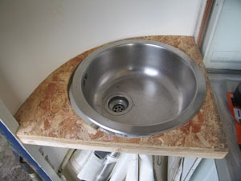

Sink: for hand-washing. Will be plumbed into water tank and rain-water-harvesting system

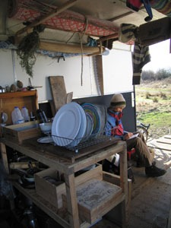

Counter: (wood) for food preparation/serving/bar and storage of pots, pans, crockery, cutlery

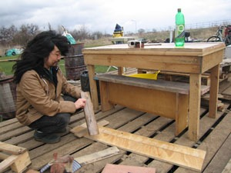

Table with two benches: (wood) movable

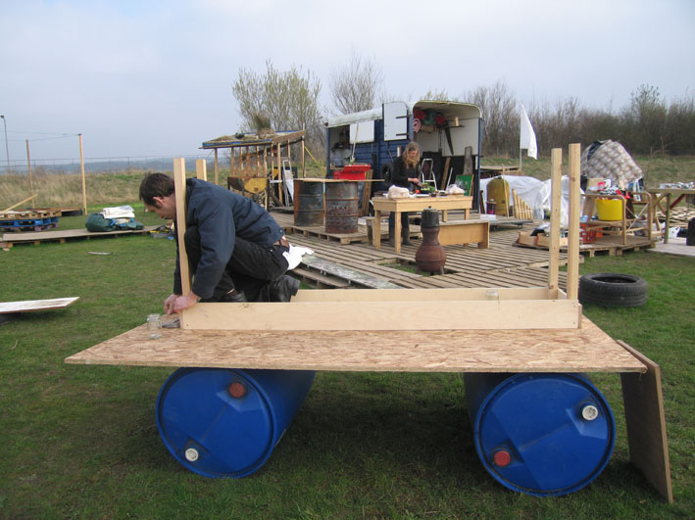

Preparation surface: (wood) movable. Storage system to be added

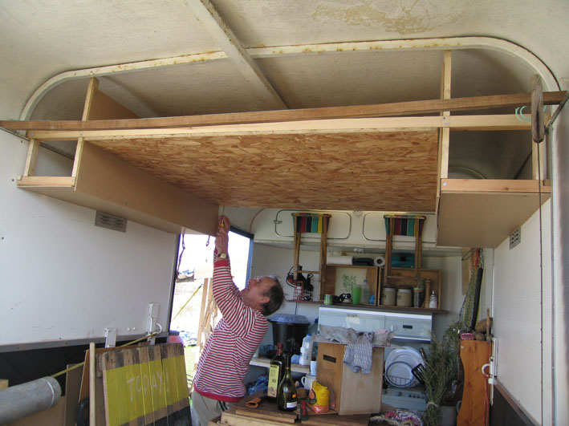

Roof storage: (wood) constructed without drilling into the trailer. Adjustments need to be made.

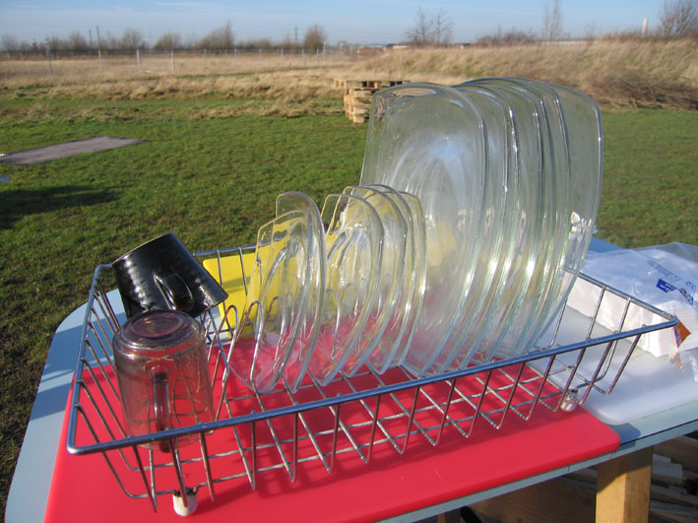

Utensils: donated crockery, cutlery, pots, pans and a wide range of communal cooking tools

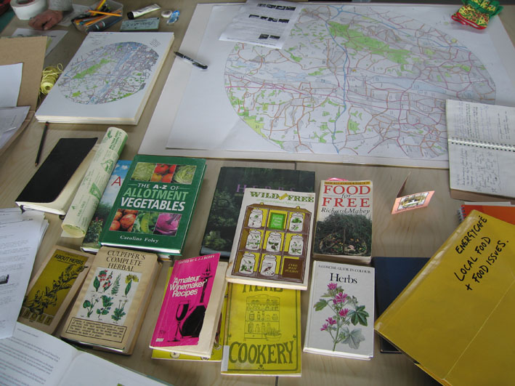

Library: Books and pamphlets on the subjects of: alternative energy, food production, wild food foraging and preparation, herbal medicine, land issues, public space and activism. A portable storage unit will be produced.

Tools: Drill, screwdrivers, hammers and basic carpentry tools. Gardening tools.

Stoves

Energy Café has a number of portable stoves that work outside the trailer. So far all are fuelled by waste or felled wood:

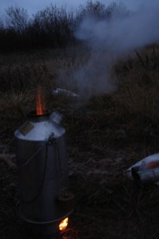

Storm kettle: commercially produced portable water boiler fuelled with dry sticks

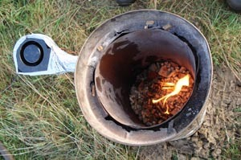

Swirl stove: invented for Energy Café and made with a metal flue, hairdryer fan and battery. Smoke free. Fuelled with sawdust pellets, waste wood-chippings, charcoal. Intensive heat good for boiling water

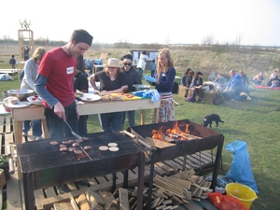

Two barbeques: made out of a steel oil drum with welded metal legs. For toasting and grilling. Fuelled with waste wood or charcoal

Other experimental portable stoves for the future
(to be produced during Energy College workshops) include:

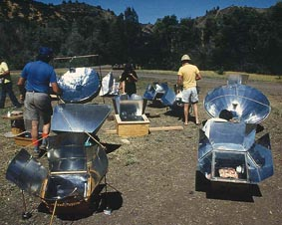

Solar cookers: made from waste materials, foil, umbrellas, wood, cardboard

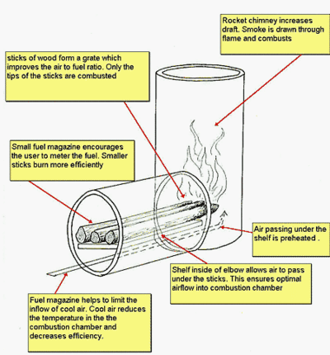

Rocket stoves: from discarded oil cans/gas bottles etc

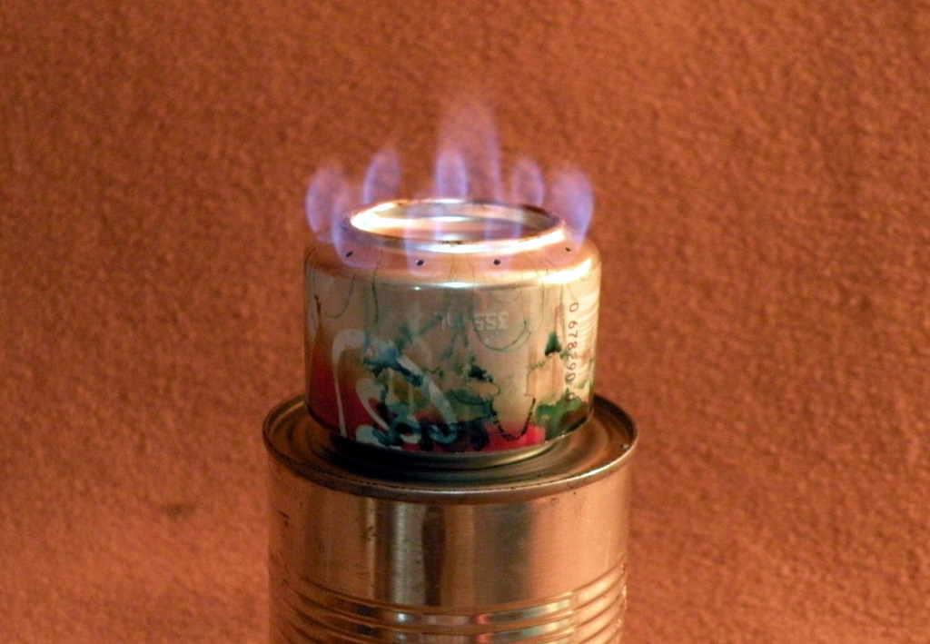

Mini stoves: from drinks cans

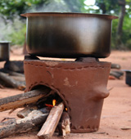

Clay stoves: made with local clay

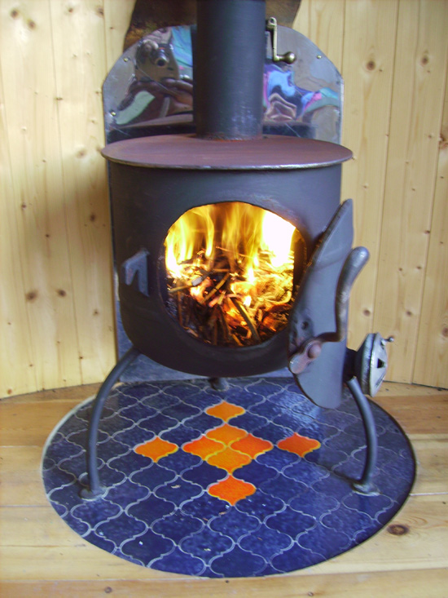

Wood burning stove made from empty Gas bottle: In future we will commission a hand-made wood burning stove for the interior of the trailer.

On-site stoves
Outdoor cooking facilities can also be made on location, for example:

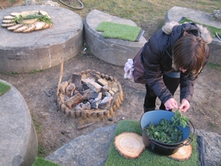

Fire pit: communal cooking and social space. Probably the earliest ever cooking method.
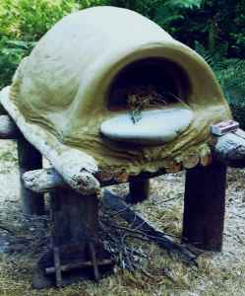

Clay oven: for baking bread, pizza etc

There is always the possibility for demonstrating and experimenting with all kinds of off-grid cooking methods. Traditional, prehistoric, ingenious, technological and global.

Experimental Off Grid-Energy Production
Energy is generated without the use of fossil fuels: gas and mains electricity. Energy Café generates its own power: experimenting with the natural elements and human energy.

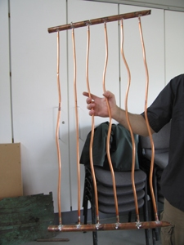

Solar hot water heater: (in progress) Hand-made invention made with copper and perspex, connected to the trailer for heating washing-up water

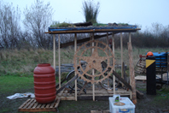

Bio-diverse bike power station: (to accompany trailer - currently dismantled) Green roof and barrel for rain-water harvesting

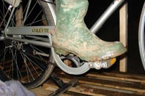

Doubles up as a self-contained unit for generating electricity with a bicycle connected to transformer and battery

